JavaScriptAjax-DynamicTable-JsonData-TdColorValue (javascript) Project pictures

Total images: 02

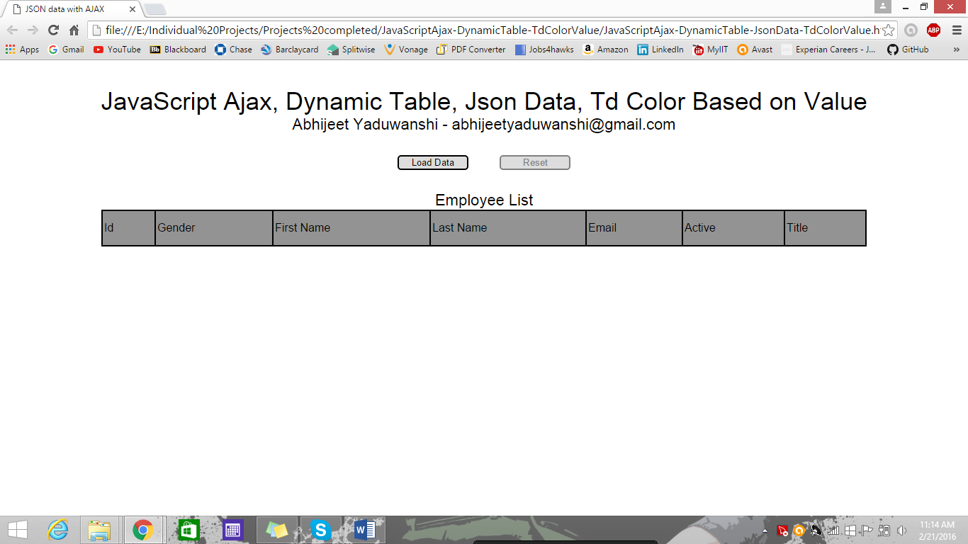

Fig 1: Home page with reset button disabled

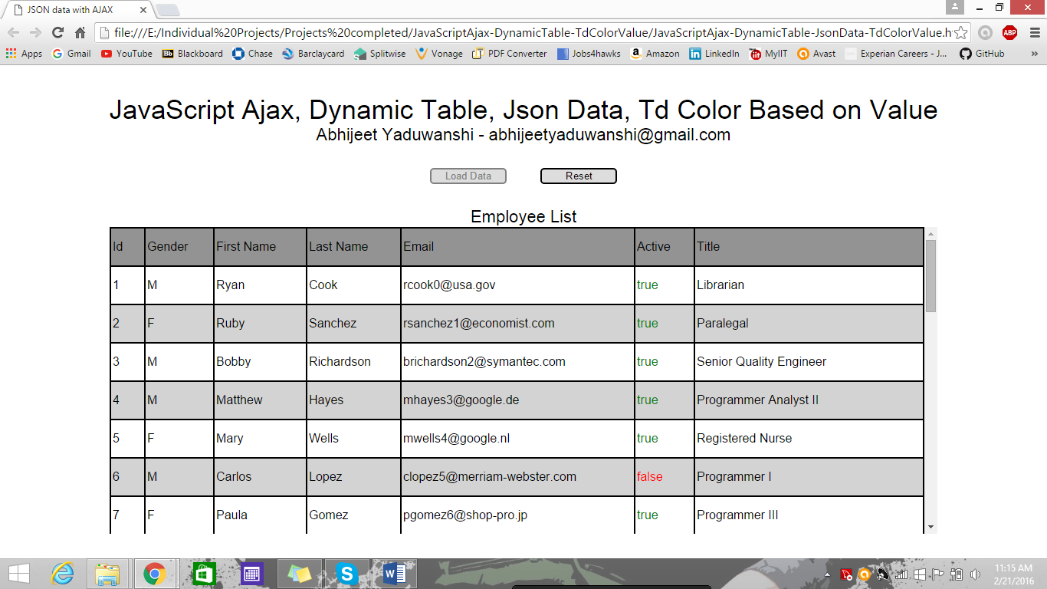

Fig 2: Data loaded with load data button disabled to stop repetition, Active column color based on values - green for true and red for false.